A Digital Lock

LAB # 10



Spring 2024
CSE-308L Digital System Design Lab

Submitted by: Ali Asghar
Registration No.: 21PWCSE2059
Class Section: C

“On my honor, as student of University of Engineering and Technology, I have neither given nor received unauthorized assistance on this academic work.”

Submitted to:
Dr. Asif Ali Khan

Date:
23rd May 2024

Department of Computer Systems Engineering
University of Engineering and Technology, Peshawar

Objectives:
This lab will enable students to:
- Build an electronic combination lock with reset button, two number buttons (0 and 1), and an unlock output. The combination should be “01011”

Software used:
- Xilinx ISE

Block Diagram:
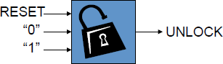
A combinational digital lock has three input buttons for Reset, entering a “0” and entering a “1” and output button UNLOCK and state which shows in which state the machine is currently in. The state output is connected to the seven segment display on the S6BOARD. The Module button in the below diagram is an abstraction of the synchronizer and level to pulse converter from the previous lab. The state transition diagram is given in the following figures.

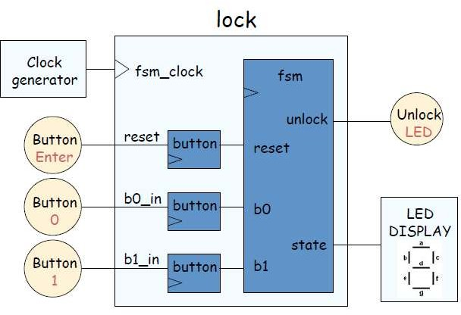

State Transition Diagram:
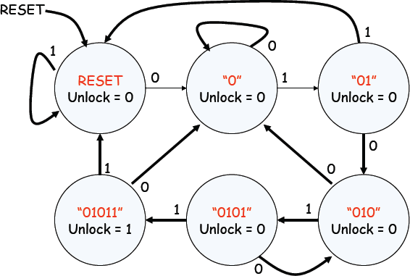

Lab Task:
Change the functionality of the lock such that it unlocks on the sequence of 11011.

Code:
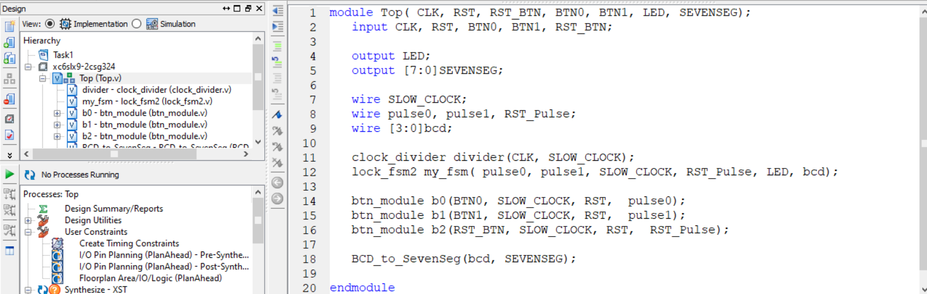
Figure 1.1 top module

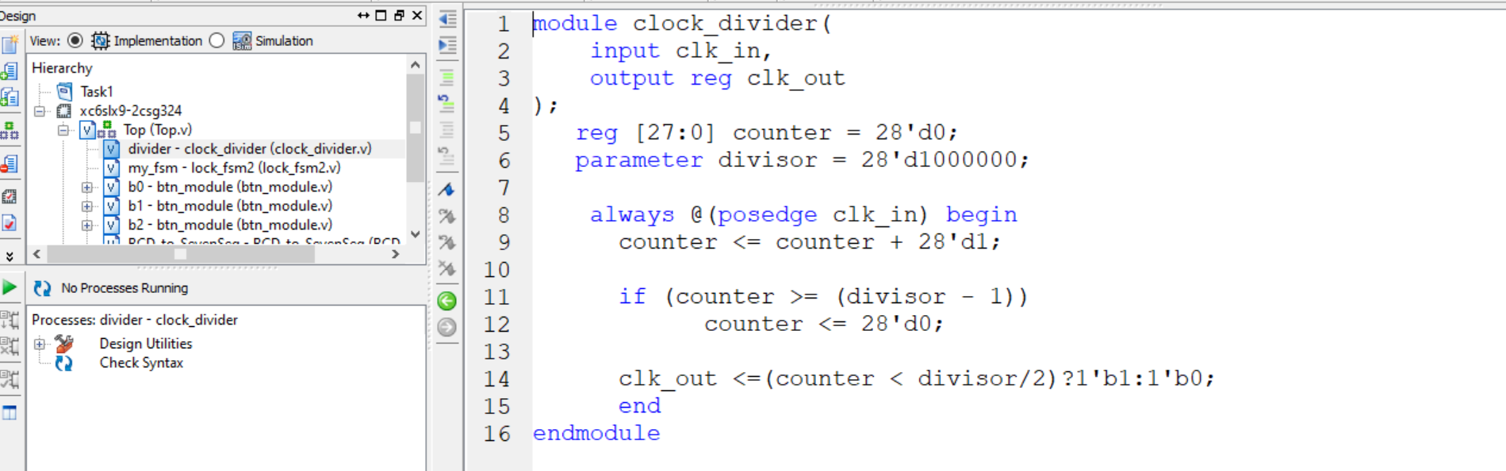
Figure 1.2: Clock Divider Code

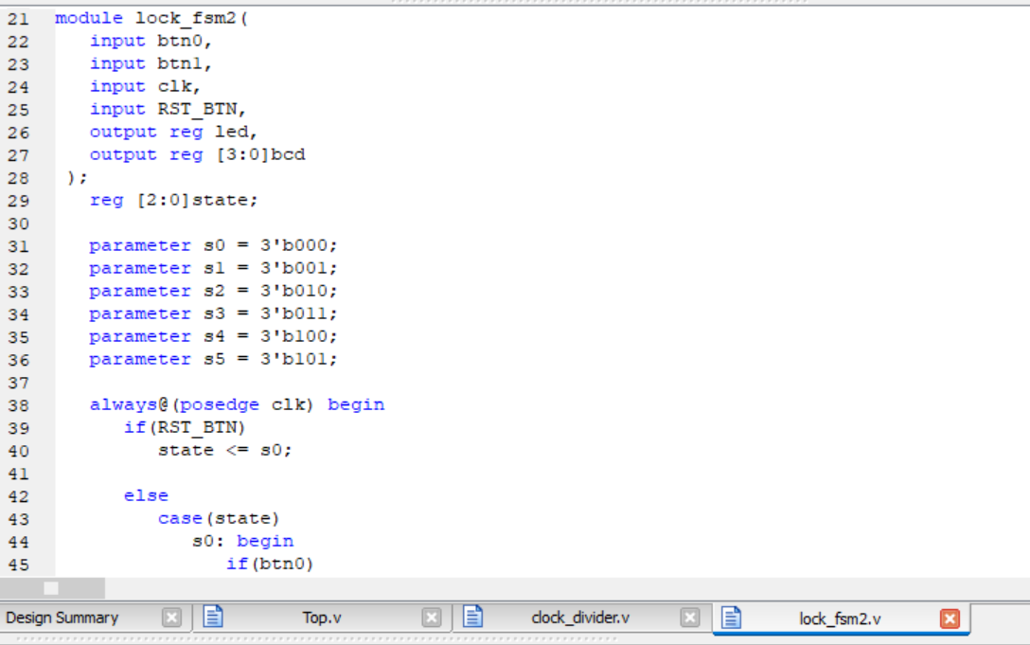
Figure 1.3.1: Digital Lock FSM Code

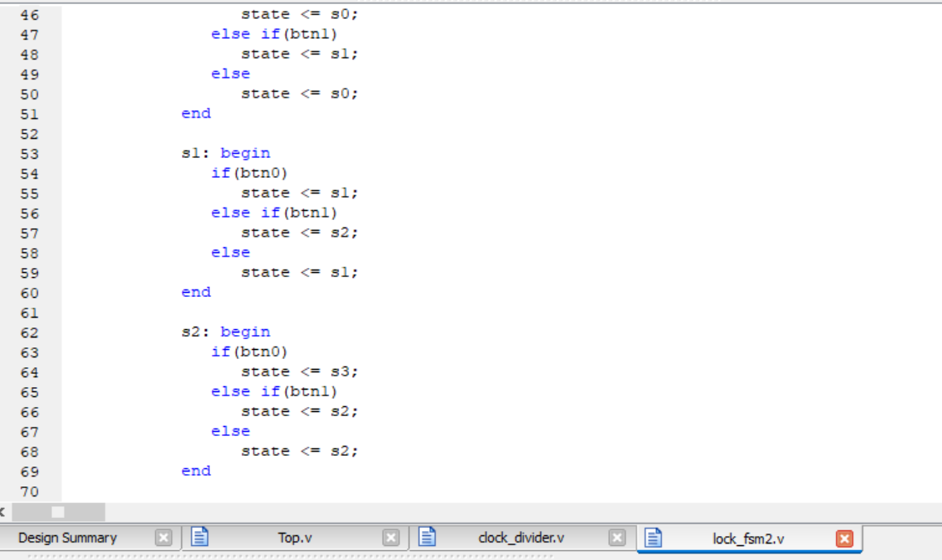
Figure 1.3.2: Digital Lock FSM Code

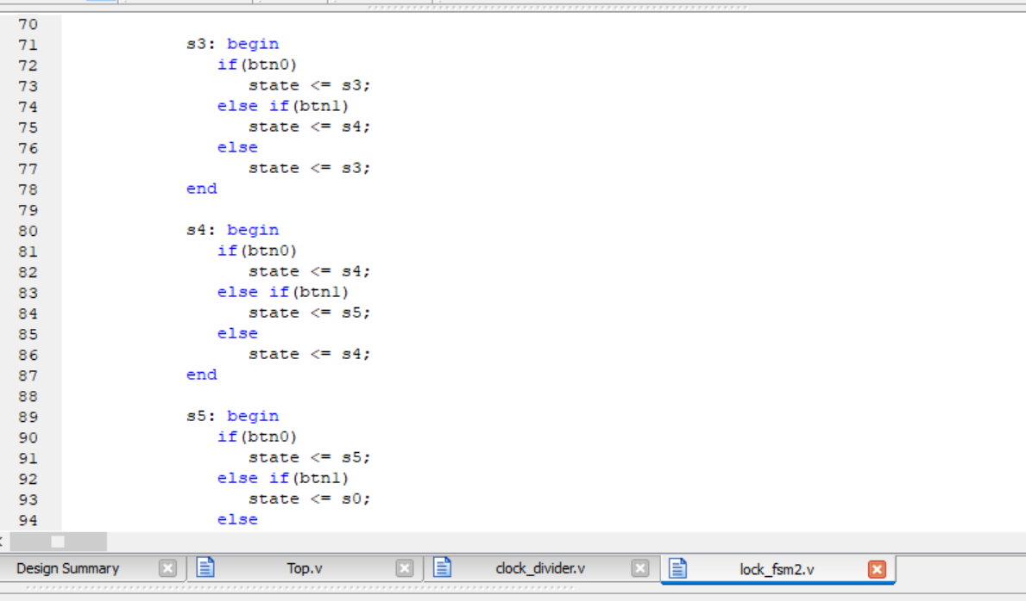
Figure 1.3.3: Digital Lock FSM Code
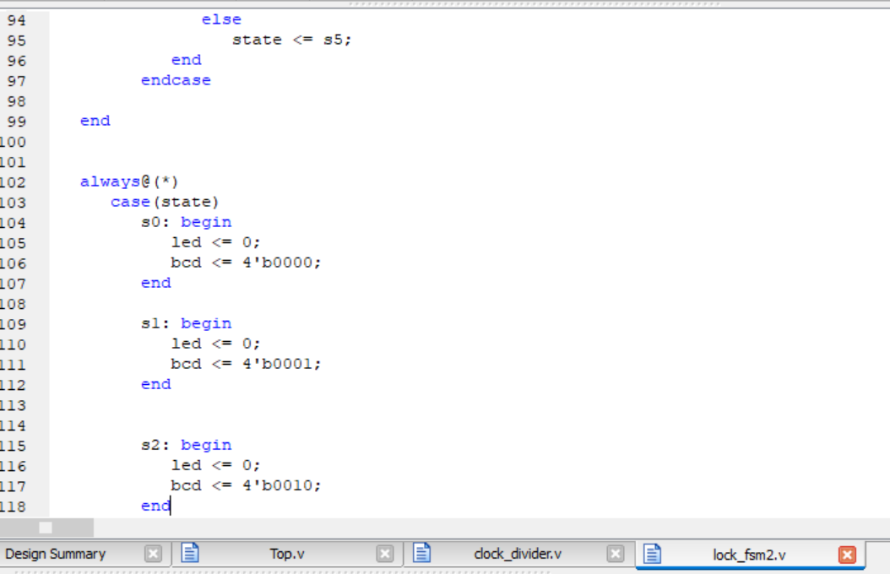
Figure 1.3.4: Digital Lock FSM Code

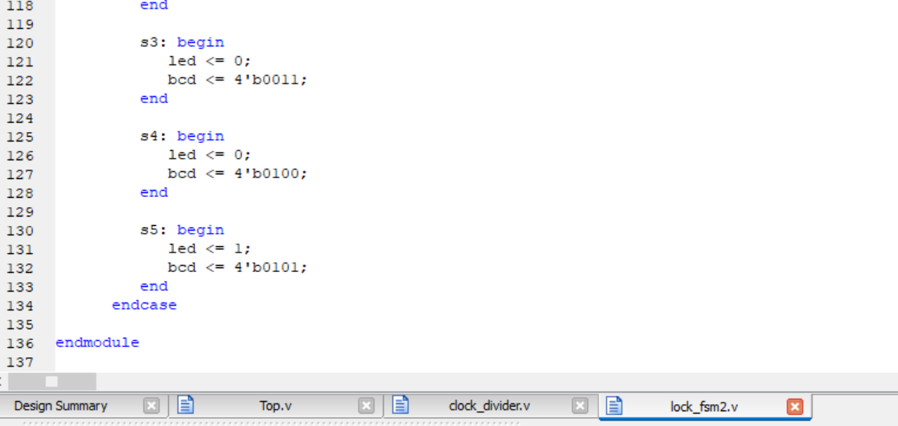
Figure 1.3.5: Digital Lock FSM Code

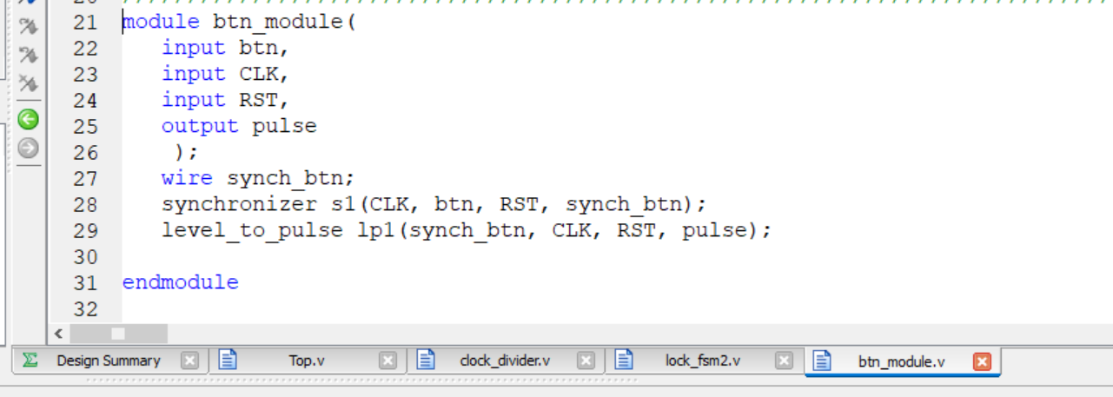
Figure 1.4: btn Module for Push Buttons

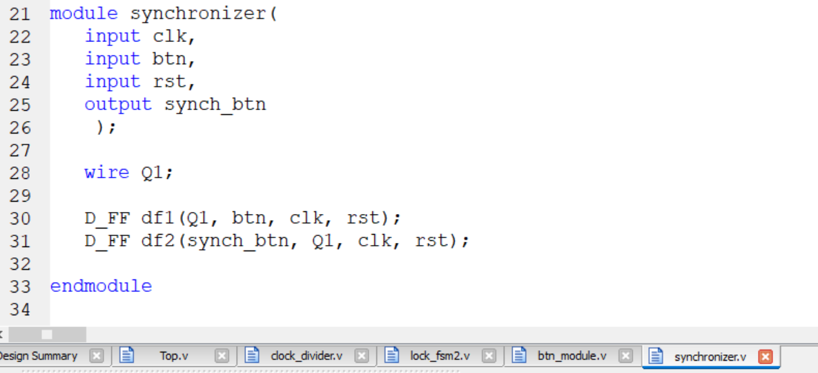
Figure 1.5: Synchronizer Code

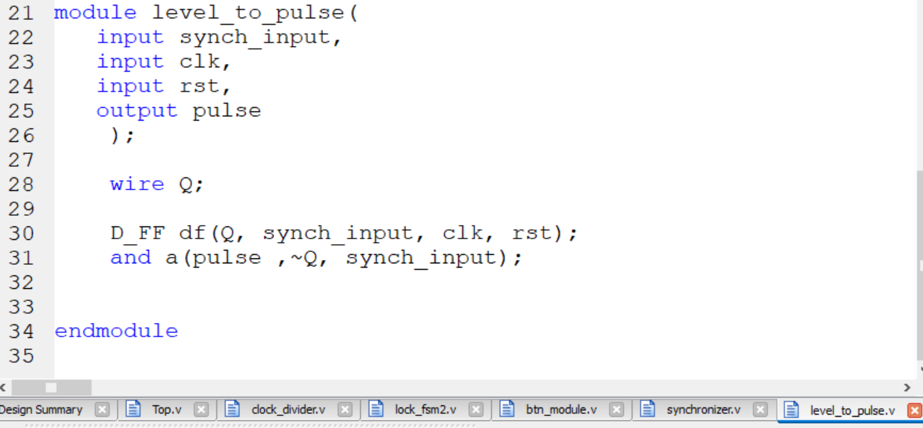
Figure 1.6: Level to Pulse Converter Code

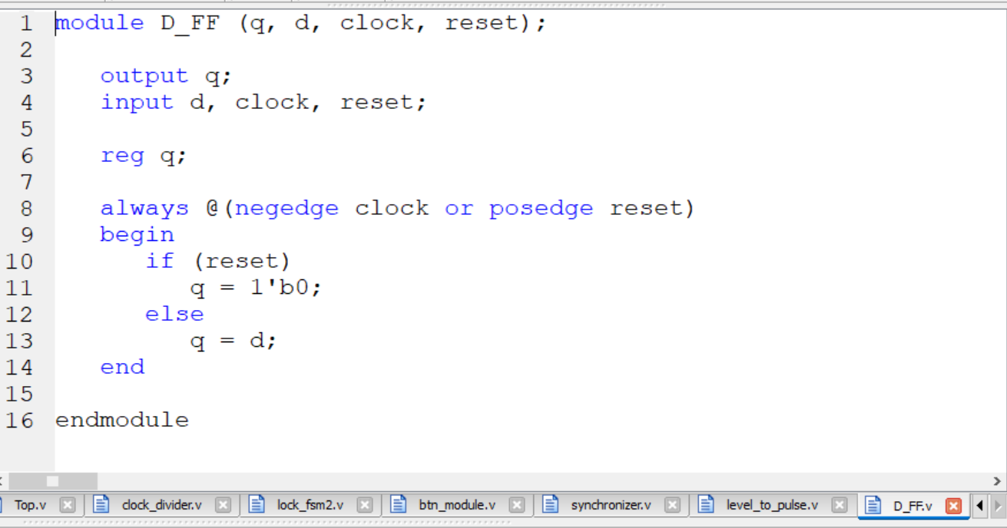
Figure 1.7: D Flip Flop Code
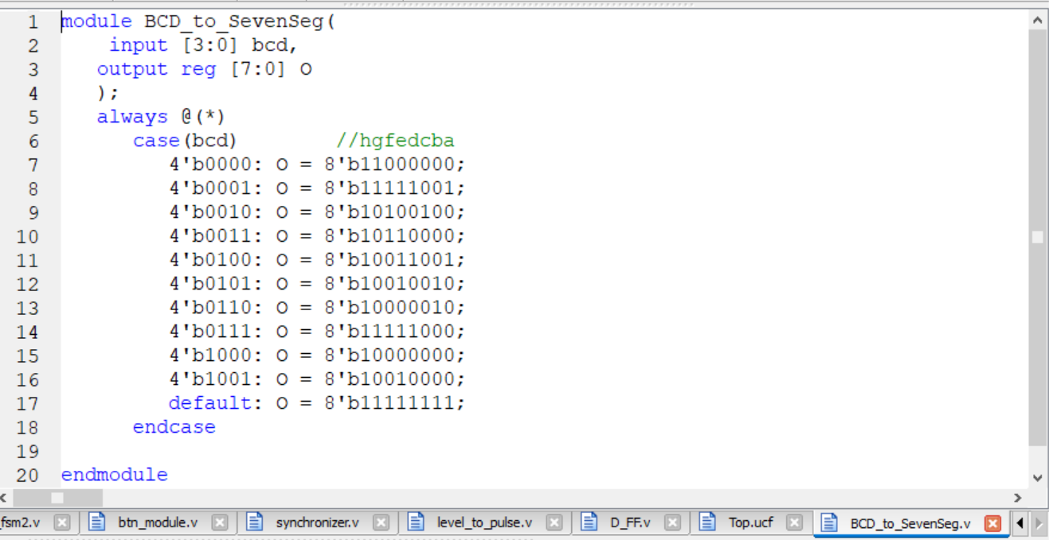
Figure 1.8: Binary Coded Decimal (BCD) to Seven Segment Decoder

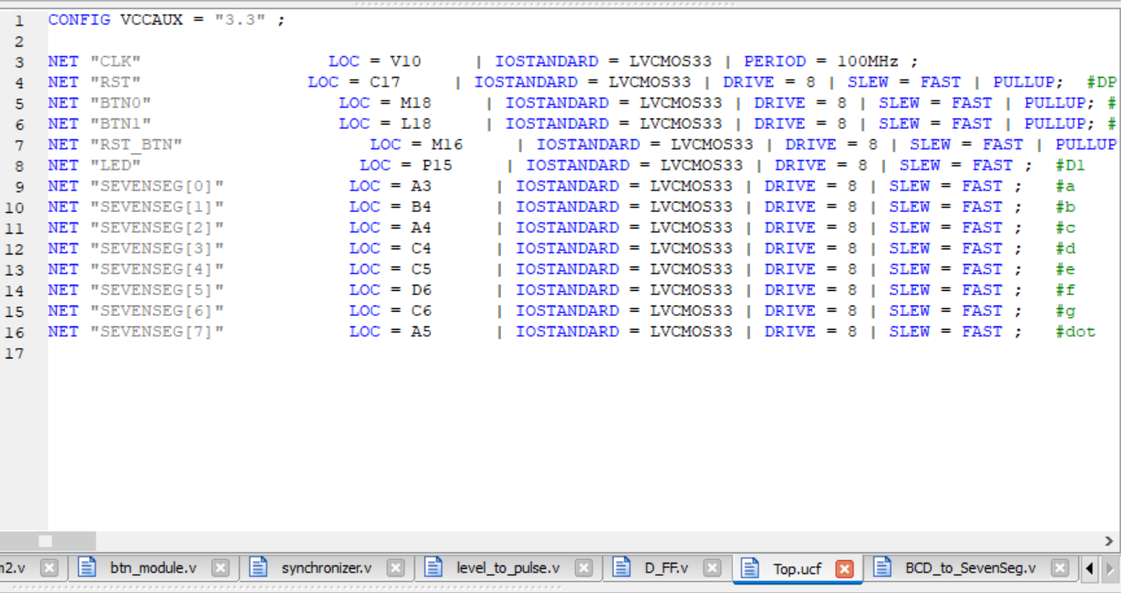
Figure 1.9: UCF File

Output:

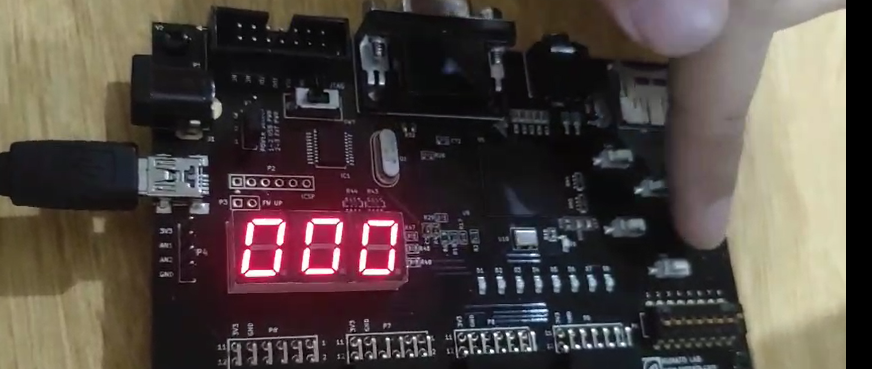
Figure 2.1: Digital Lock Implementation on Spartan6 FPGA Board (State S0)

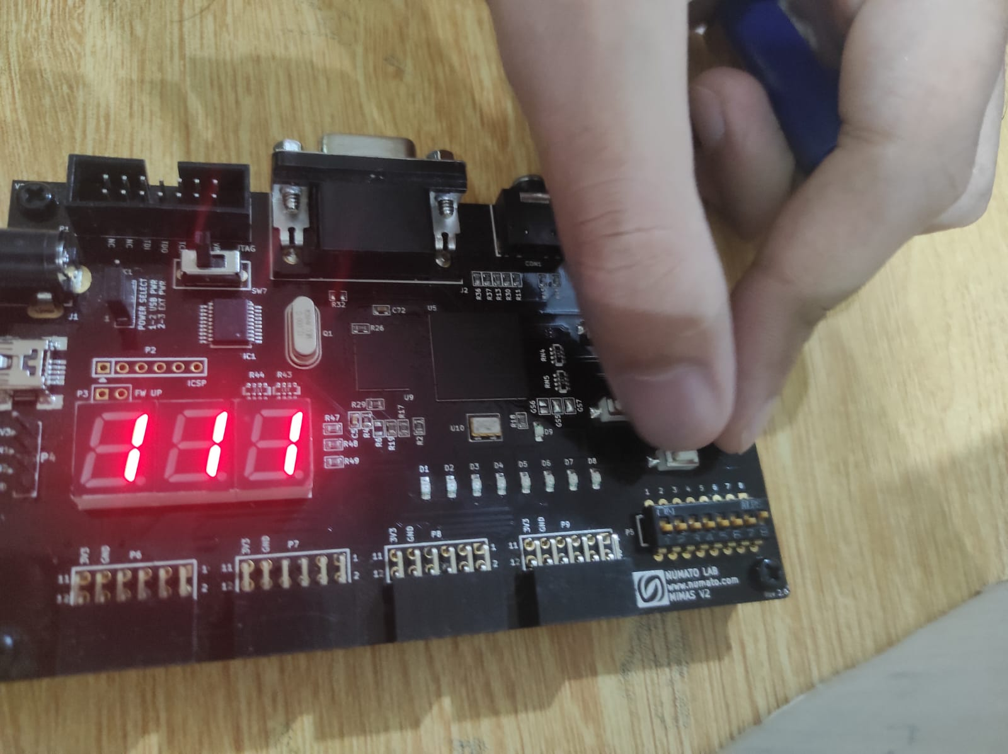
Figure 2.2: Digital Lock Implementation on Spartan6 FPGA Board (State S1)

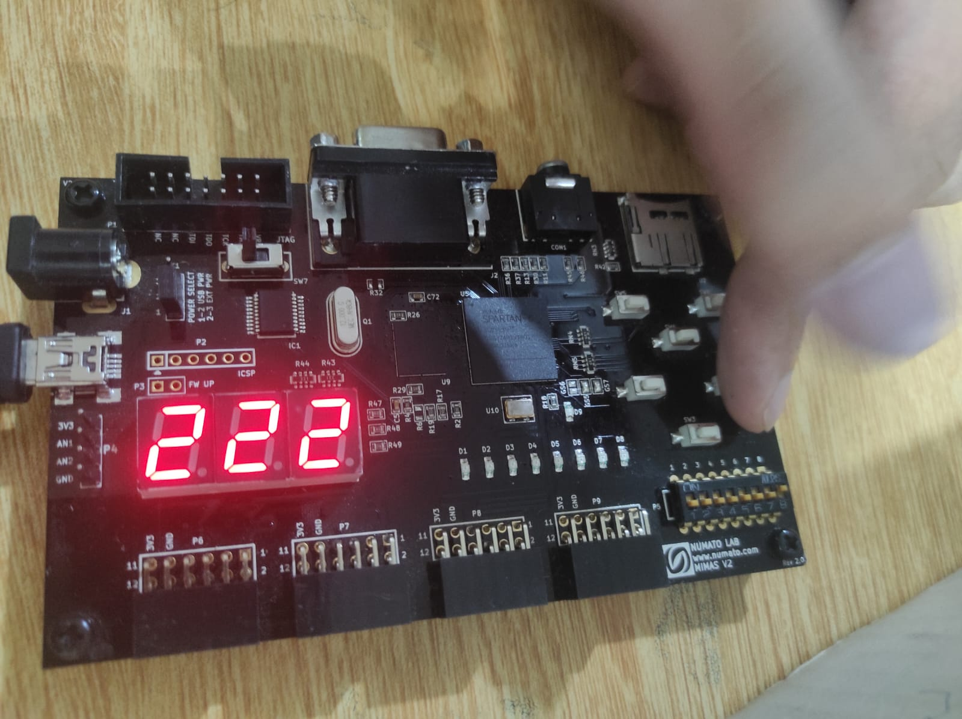
Figure 2.3: Digital Lock Implementation on Spartan6 FPGA Board (State S2)

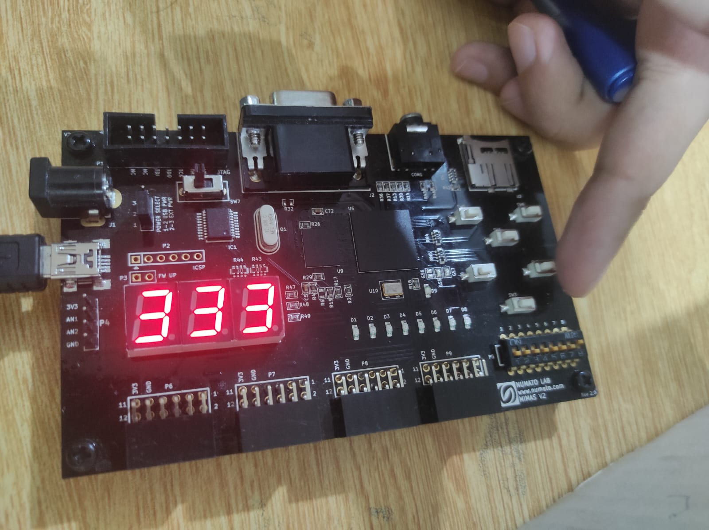
Figure 2.4: Digital Lock Implementation on Spartan6 FPGA Board (State S3)
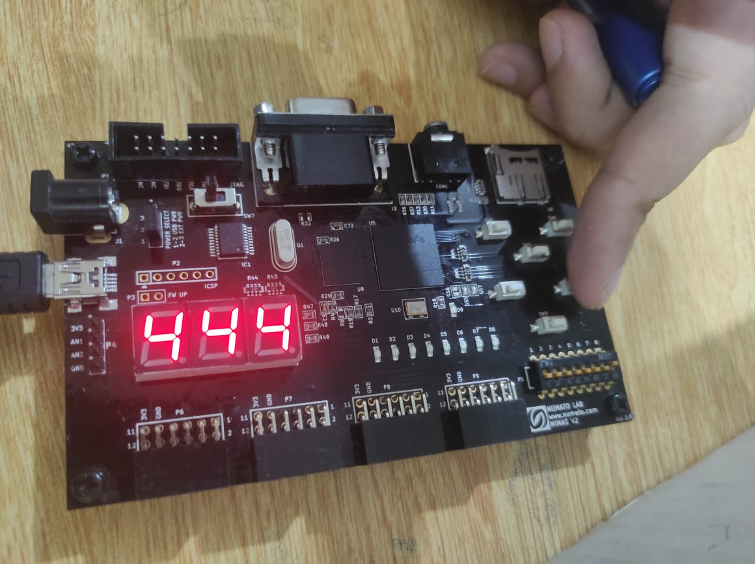
Figure 2.5: Digital Lock Implementation on Spartan6 FPGA Board (State S4)

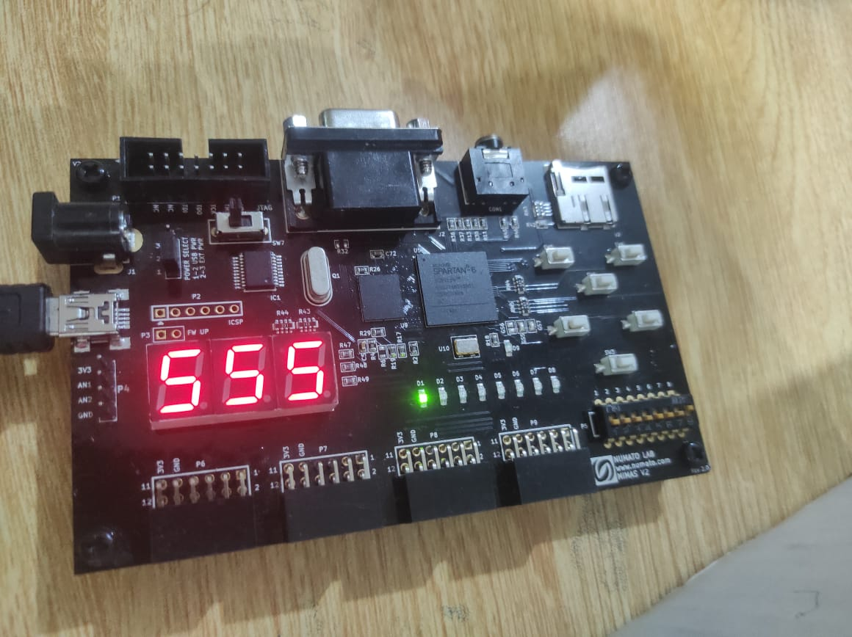
Figure 2.6: Digital Lock Implementation on Spartan6 FPGA Board (State S5)

